<https://www.youtube.com/watch?v=Rtd0gHl4PBo>

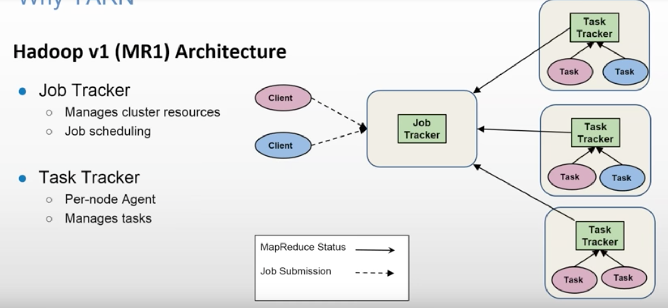

Limitations of Hadoop 1

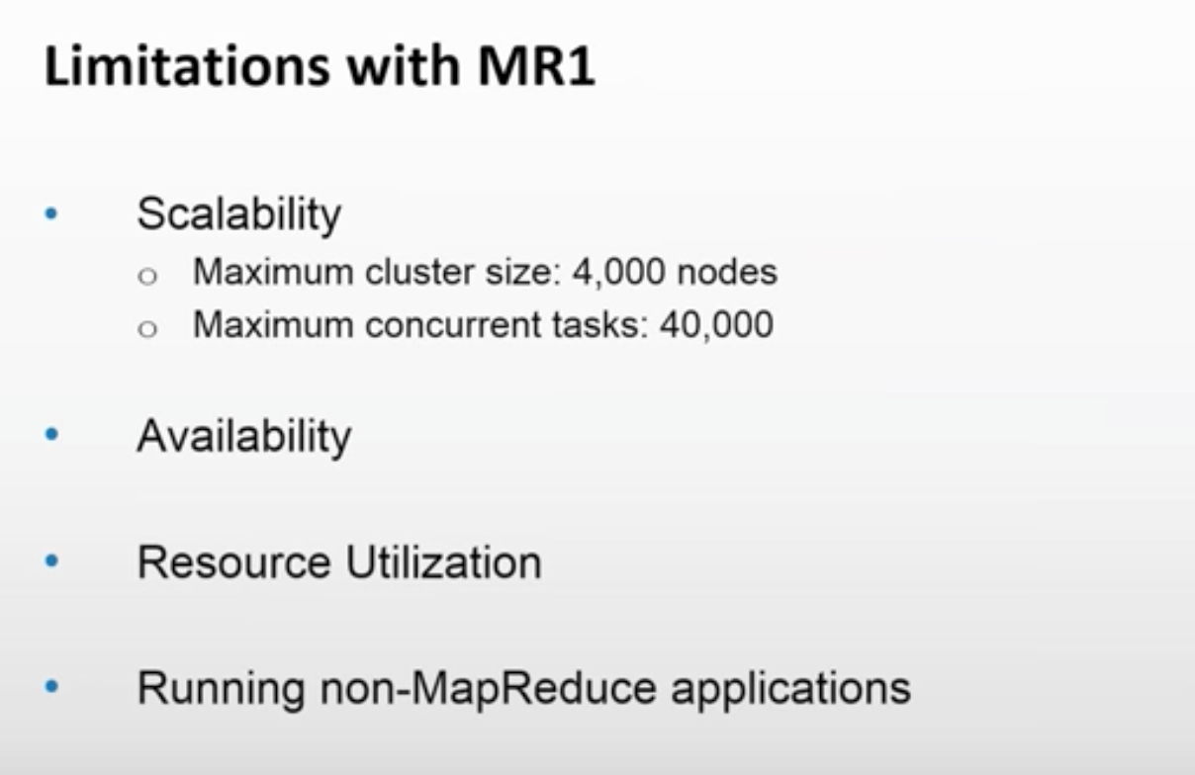

JobTracker is a SPOF. Only traditional MapReduce code can run on Hadoop V1. You cannot run other apps like Storm, Spark, Giraph etc.

*Scalability*

YARN can run on larger clusters than MapReduce 1. MapReduce 1 hits scalability bottlenecks in the region of 4,000 nodes and 40,000 tasks,6 stemming from the fact that the jobtracker has to manage both jobs *and* tasks. YARN overcomes these limitations by virtue of its split resource manager/application master architecture: it is designed to scale up to 10,000 nodes and 100,000 tasks.

In contrast to the jobtracker, each instance of an application—here, a MapReduce job—has a dedicated application master, which runs for the duration of the application.

*Availability*

the large amount of rapidly changing complex state in the jobtracker’s memory (each task status is updated every few seconds, for example) makes it very difficult to retrofit HA into the jobtracker service.

With the jobtracker’s responsibilities split between the resource manager and ap‐ plication master in YARN, making the service highly available became a divide- and-conquer problem: provide HA for the resource manager, then for YARN ap‐ plications (on a per-application basis). And indeed, Hadoop 2 supports HA both for the resource manager and for the application master for MapReduce jobs.

*Utilization*

In MapReduce 1, each tasktracker is configured with a static allocation of fixed-size “slots,” which are divided into map slots and reduce slots at configuration time. A map slot can only be used to run a map task, and a reduce slot can only be used for a reduce task.

In YARN, a node manager manages a pool of resources, rather than a fixed number of designated slots. MapReduce running on YARN will not hit the situation where a reduce task has to wait because only map slots are available on the cluster, which can happen in MapReduce 1. If the resources to run the task are available, then the application will be eligible for them.

Furthermore, resources in YARN are fine grained, so an application can make a request for what it needs, rather than for an indivisible slot, which may be too big (which is wasteful of resources) or too small (which may cause a failure) for the particular task.

*Multitenancy*

In some ways, the biggest benefit of YARN is that it opens up Hadoop to other types of distributed application beyond MapReduce. MapReduce is just one YARN ap‐ plication among many.

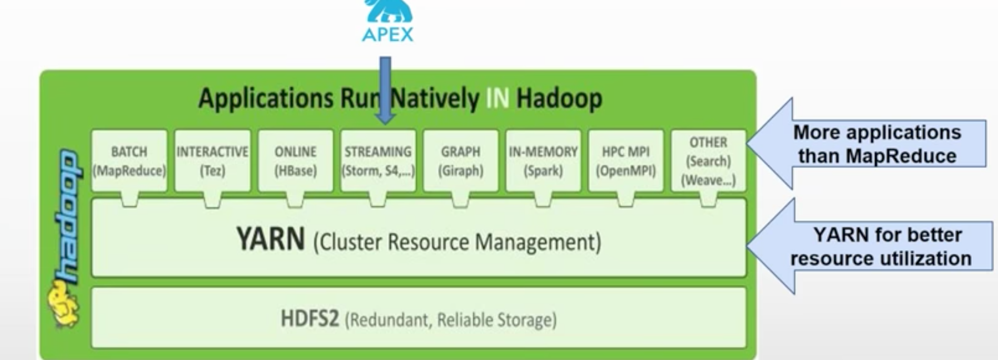

YARN has taken Hadoop beyond Batch Processing.

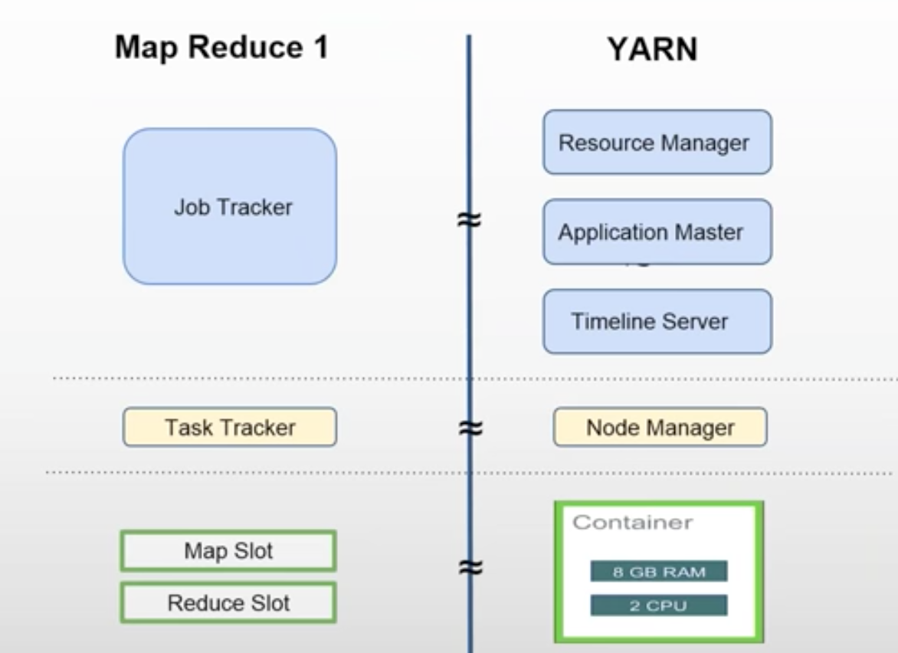

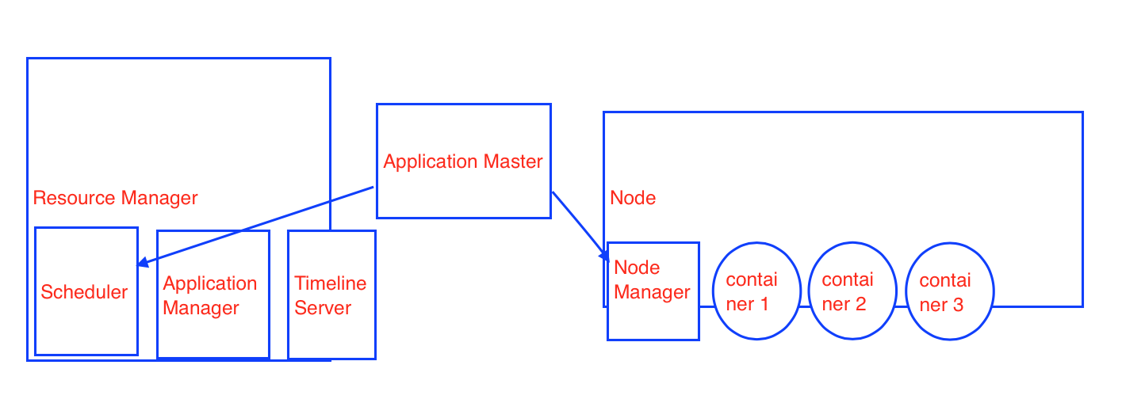

In Hadoop V1, Job Tracker used to many work. In YARN, responsibilities are divided.

Timeline Server keeps the history of all the jobs that were executed.

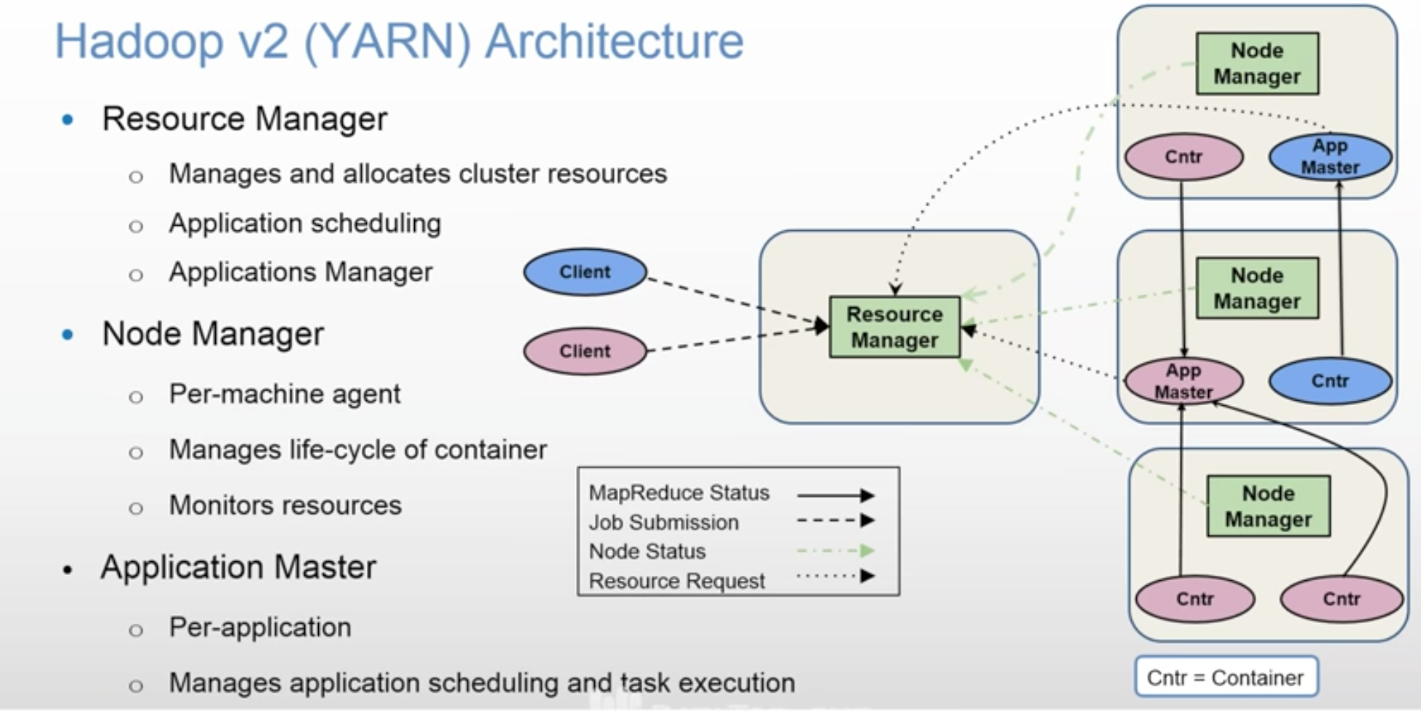

As there are two applications, there are two Application Masters shown in above diagram.

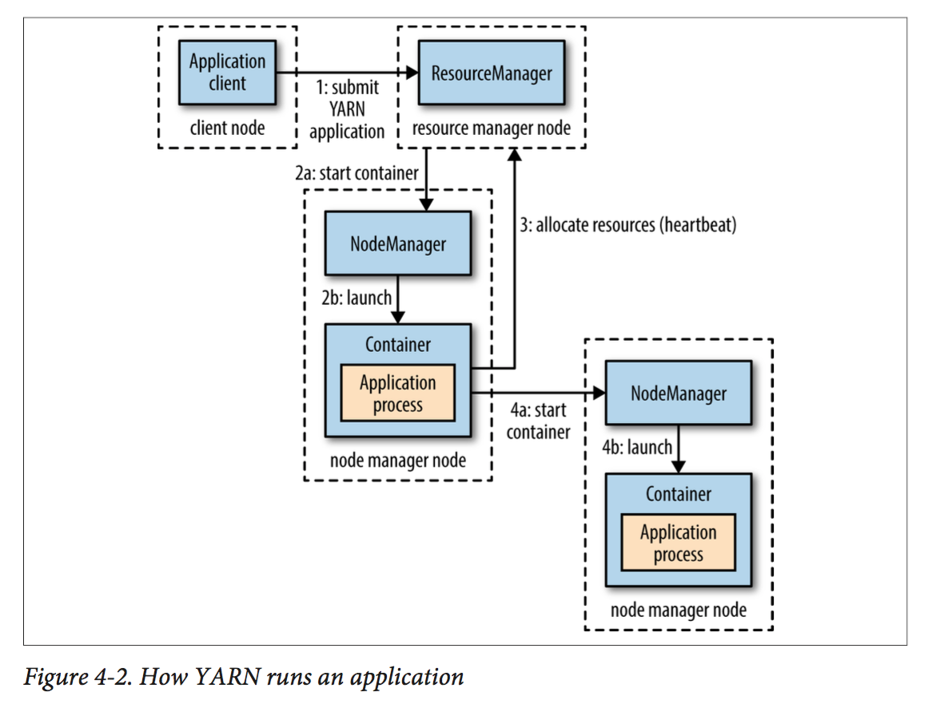

**Application Master** sits in between Resource Manager and Node Manager.

There is one Application Master per Application.

It negotiates number of containers from RM’s Scheduler and then contacts NMs on nodes and tells them to launch containers.

You submit a job to RM. RM’s scheduler schedules the job.

**Node Manager** keeps sending heart beats to RM, so that RM know what NMs are up. It also sends utilization of resources information to RM.

Node Manager is responsible to launch a container and killing it when job is over.

**Scheduler** will schedule the job in the cluster. So, your job’s state changes from

accepted to running.

3 different types of schedulers available:

- FIFO

- Capacity

- Fair Share

You can configure it in yarn-site.xml

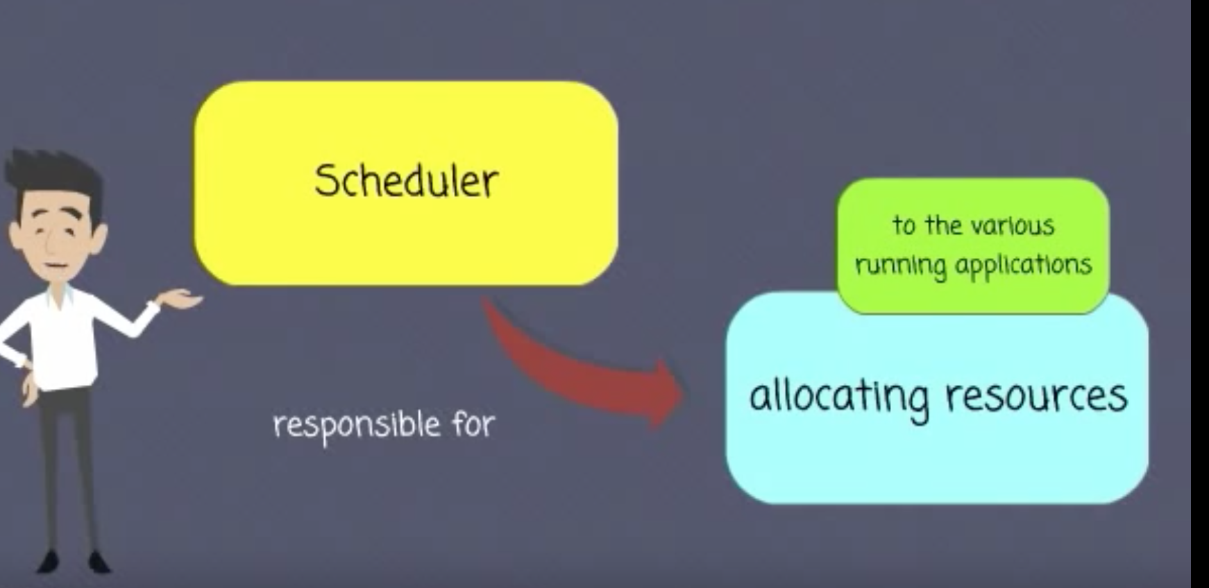

**Timeline server** keeps history of jobs that were executed.

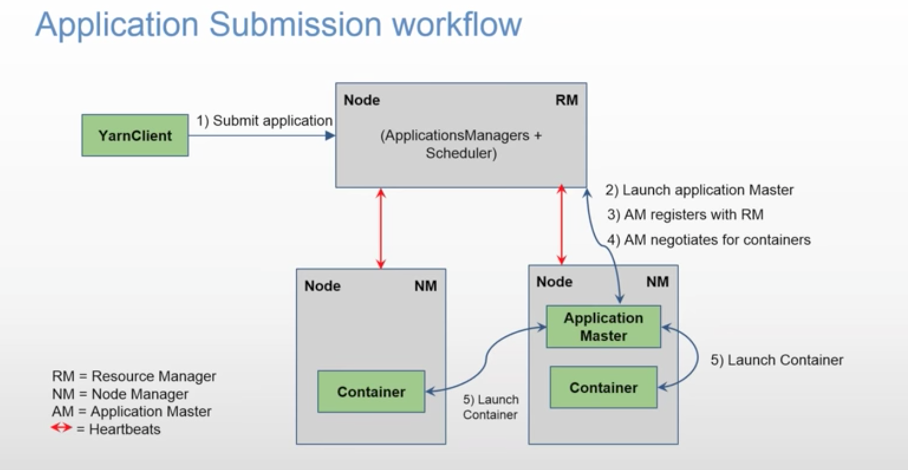

Yarn Client submits a job to RM with some specification like how much cpu, memory etc required to launch an Application Master. Remember, only one Application Master is lauched per application.

RM’s **Application Manager** launches Application Master on a node that is available. Application Master also runs inside the container.

Application Master holds your MapReduce jar file.

Application Master will register itself to RM telling it is running on a particular node.

**Application Master** Negotiates containers with RM with so and so specifications of cpu, memory etc. Then it will ask Node Managers to launch containers.

Application Master will unregister itself from RM once the job is completed.

How the communication happens between RM and Application Master?

Application Master is a custom code. If it requires 3 containers, but RM has only 2 available, then RM can go back to Application Master saying come back after some time or you can write Application Master code in such a way that it can accept lower number of containers also.

YARN allows an application to specify locality constraints for the containers it is requesting. Locality constraints can be used to request a container on a specific node or rack, or anywhere on the cluster (off-rack).

Sometimes the locality constraint cannot be met, in which case either no allocation is made or, optionally, the constraint can be loosened.

As per the proximity and availability of the nodes, YARN schedules your job.

It tries to run the job on the closest node where block replica is available. If node is busy because of other containers running in it, then

it finds another node in the same rack. If that is also not available then it goes to a node on another rack.

In the common case of launching a container to process an HDFS block (to run a map task in MapReduce, say), the application will request a container on one of the nodes hosting the block’s three replicas, or on a node in one of the racks hosting the replicas, or, failing that, on any node in the cluster.

Failure:

You can have Stand By RM. So, if primary RM fails, then Stand By RM is promoted as primary RM.

How does it handle long running jobs?

Jobs can be run for months long. Hadoop takes care of failure of nodes.

How Application Master is started?

RM can launch it on any available Node based on its availability.

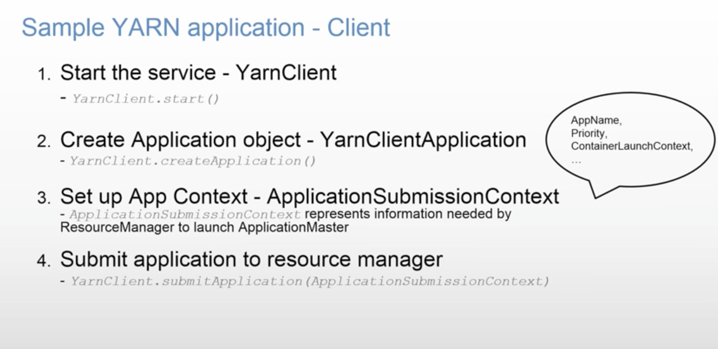

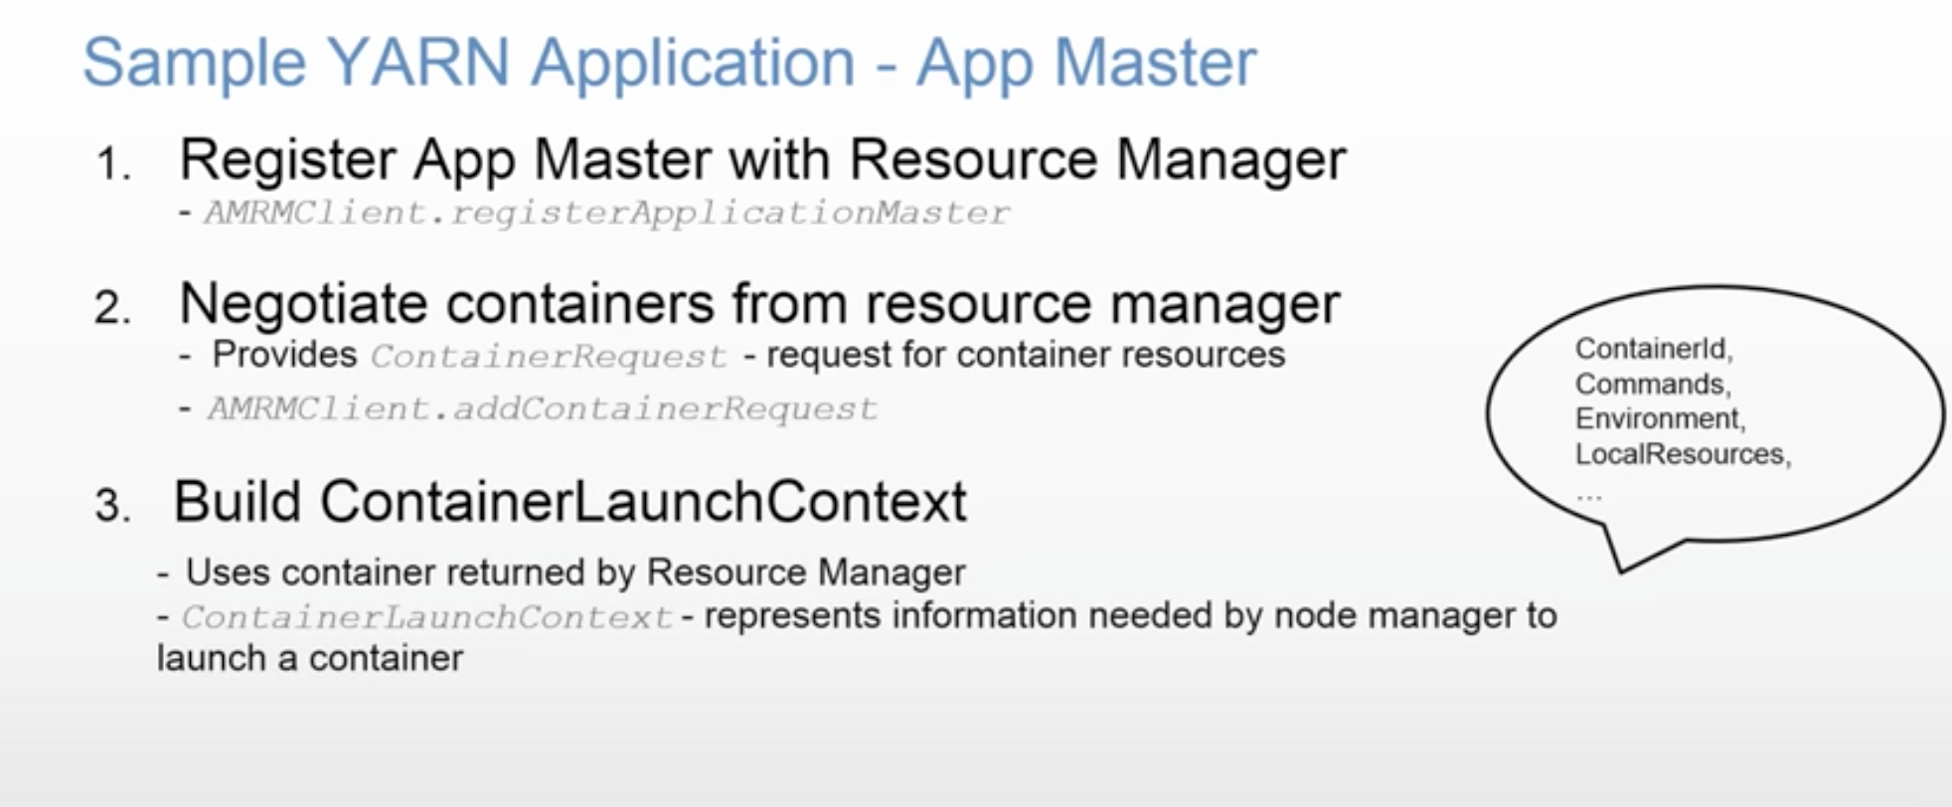

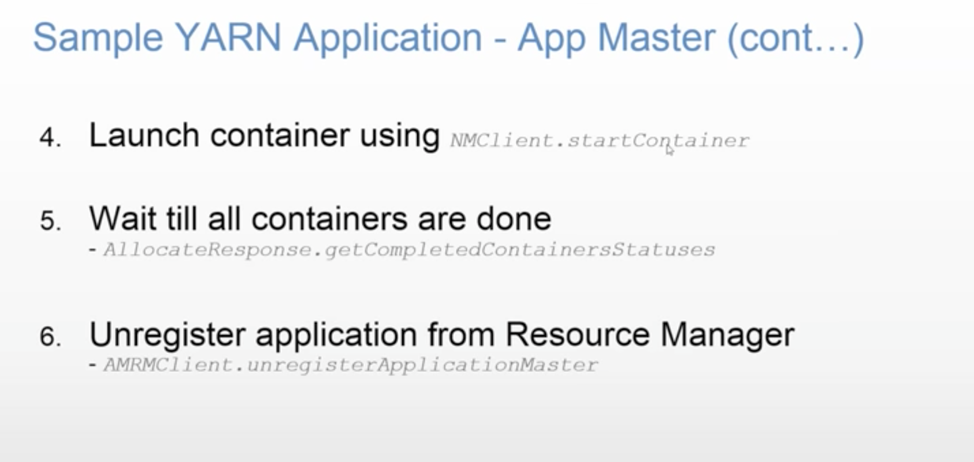

You might have a need where two containers needs to share data. You can configure locality of the containers to be on the same node, so that they don’t use much network. Ideally, you should write independent applications.

